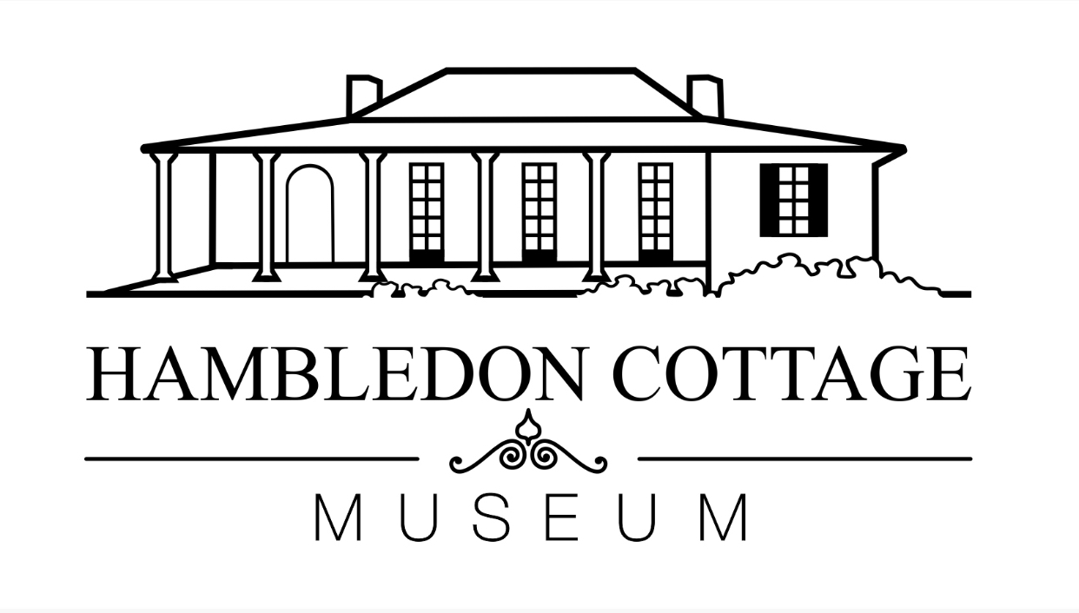
STAGE 2 ACTIVITY SHEET
STAGE 2 – ACTIVITY SHEET
‘FIRST CONTACTS’
CHOOSE 4 OBJECTS FROM THE TOUR OF HAMBLEDON COTTAGE
- TWO THAT REPRESENT THE BURRAMATTAGAL PEOPLE AND
- TWO REPRESENTING THE EUROPEAN SETTLERS
ONCE THEY HAVE BEEN DRAWN, WRITE;
- WHAT THE OBJECT IS.
- WHAT THE OBJECT IS USED FOR.
- AND WHAT OBJECT YOU WOULD USE NOW IN YOUR HOUSE INSTEAD.

OBJECT 4
OBJECT 3
OBJECT 2
OBJECT 1
MJZSHDJDIJDSWOWS=WWED

