**AUSTRALIAN COLONIES**

STAGE 3 ACTIVITY WORKSHEET

THE QUESTIONS BELOW ARE BASED ON THE PEOPLE AND STORIES YOU HAVE SEEN AND HEARD THROUGHOUT THE TOUR OF HAMBLEDON COTTAGE MUSEUM

ANSWER THEM ALL TO COMPLETE THE CROSS WORD

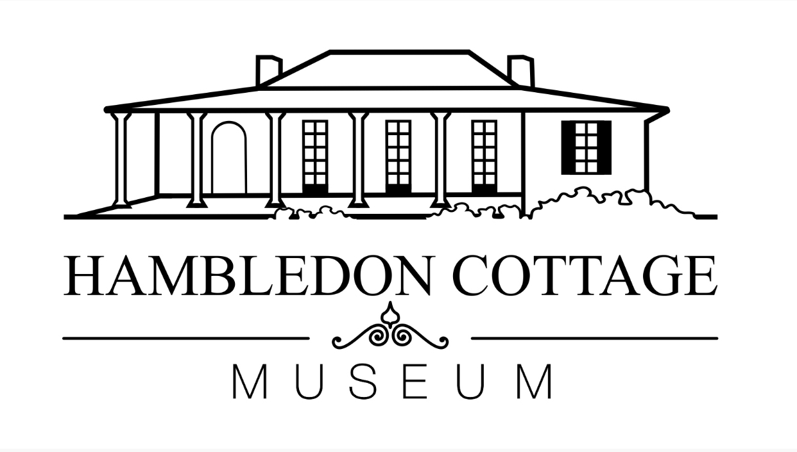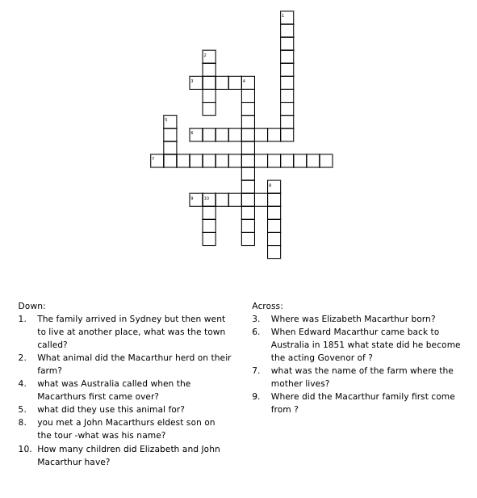

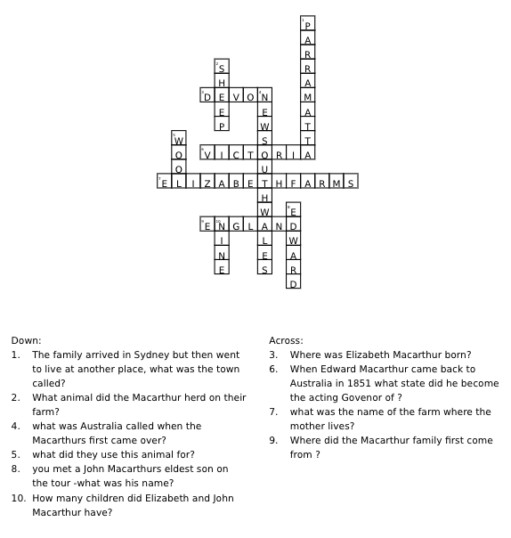**ANSWER KEY**